
K&M Tire

AG – OTR Manager
11/5/21

Document Number:
Contract Number:

Table of Contents
1. K&M Tire 1
1.1 K&M Timeline 3
1.2 Important Company Information 3
2. Office Manual Introduction 5
3. Welcome 6
4. Overview 7
4.1 Conventions 7
4.2 Cautions & Warnings 7
5. AG / OTR Sales Managerial Expectations 8
5.1 Guide and direct AG / OTR specialist team to grow specified segment of business 8
5.2 Maintain communication between regional sales managers to keep all parties updated 8
5.3 Openly communicate with manufacturer reps and managers 8
5.4 Support AG / OTR Specialists with special requests / projects from customers 9
5.5 Support purchasing and inventory with input from the field 9
6. Frequently Asked Questions 11
7. Other 12
Appendix A: Miscellaneous 13
Appendix B: Supportive Department Summaries 14
Appendix C: Glossary 15
Appendix D: Referenced Documents 16
Appendix E: Approvals 18
Appendix F: Additional Appendices 19
Appendix G: Notes to the Author/Template Instructions 20
Appendix H: Revision History Tracking 21

- List of Figures
No table of figures entries found.

- List of Tables
Table 1 - Support Points of Contact 115
Table 2 - Acronyms 119
Table 3 - Glossary 121
Table 4 - Referenced Documents 122
Table 5 - Approvals 124
Table 6 - Revision History Tracking 127

K&M Tire
Video about K&M Tire

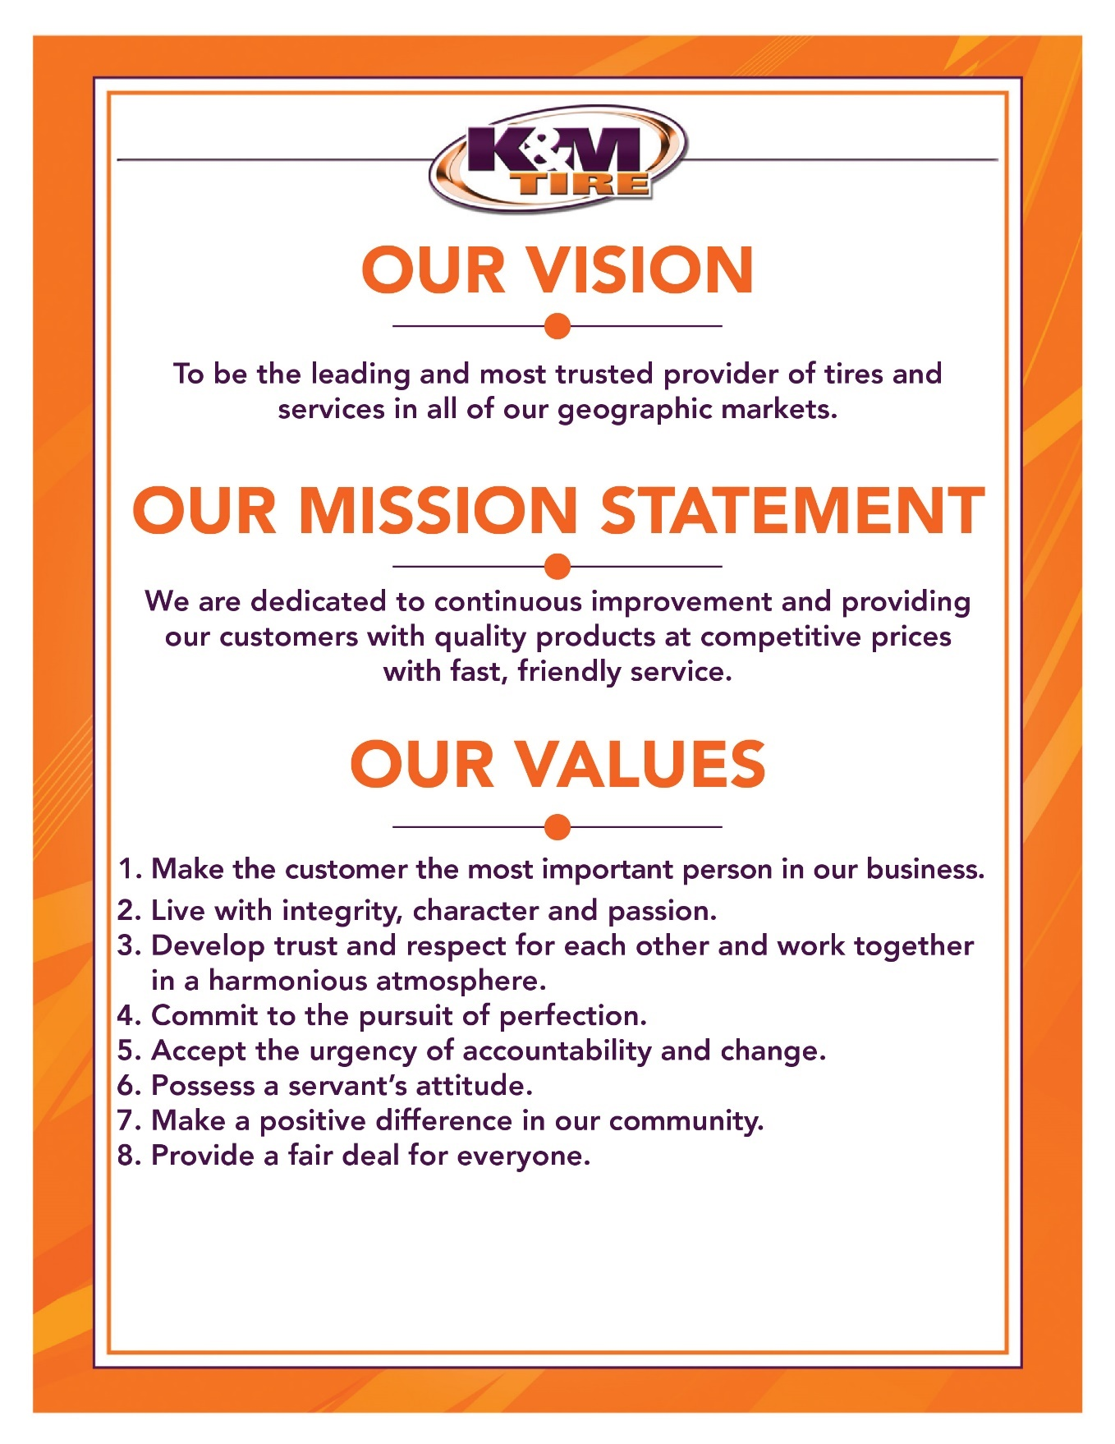

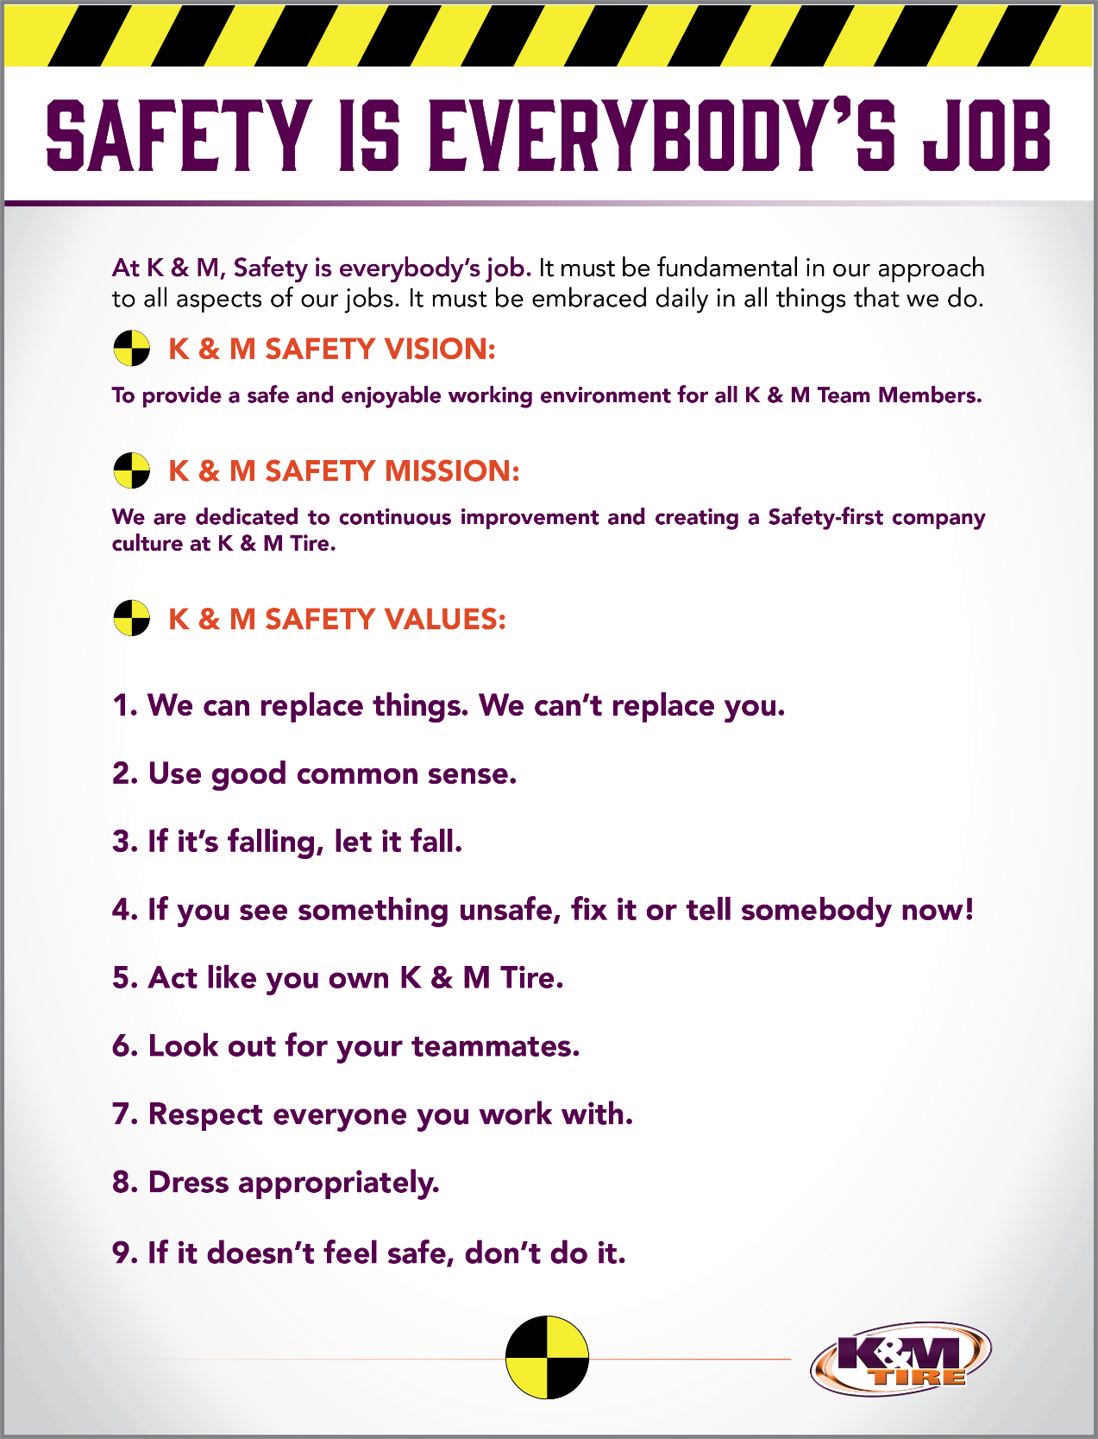

K&M Timeline
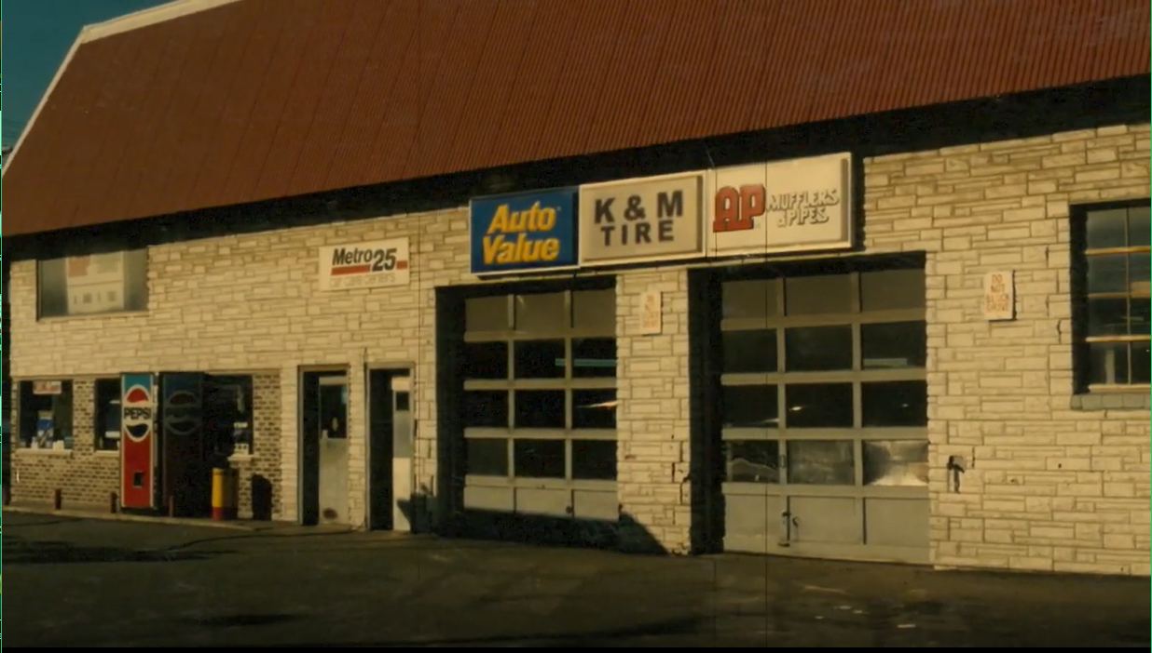

Important Company Information
This information is updated frequently. To ensure you are viewing the most current and accurate information, please use the links to access each document.

Employee Handbook
Employee Handbook can be found in Paylocity under Self – Service Portal then unemployment and is accessible HERE.

Organizational Chart
The organizational chart is a breakdown showing who is on each team and the chain of command throughout the entire company starting with the CEO and President. It is maintained on Paylocity and is accessible HERE.
Our Locations:
http://kmtire.com/km-cgi/distmap

Warehouse Locations - Contact Information
The Warehouse Locations – Contact Information is a Word document listing each of our warehouse locations’ addresses, a phone number to reach the warehouse/manager, the manager’s name and an email address for to reach the warehouse manager directly as well as a “location” email. When sending an email to the location email address, it will be sent to anyone associated with that warehouse who has an active email address. This list is maintained by our Human Resources department and can be found on the F: Drive. You can also view the list by clicking HERE.

K&M Tire US Footprint
Click on the below link to see the footprint map
http://kmtire.com/km-cgi/distmap

Office Manual Introduction
This manual is intended to provide helpful information for any person working in various Outside Sales positions with K&M Tire. It will be especially helpful for those newly hired or new to an Outside Sales position. There will be some step-by-step procedural suggestions. This manual, however, does not replace the necessity to work closely with your sales manager for guidance when needed.

Welcome
Welcome to the K&M Tire family and Outside Sales Team! We are pleased you decided to become part of our positive culture and strive to make our company the leading and most trusted tire distributor. Our #1 Value is to make the customer the most important person in our business, and that starts with you. We have many tools to help you along the way and we understand that it can be overwhelming in the beginning. Do not hesitate to ask for help; like family we are all here to support you.
In the Ag/OTR Sales Manager position, you will manage our Ag/OTR Specialist Team. It would be impossible to include everything in such a short letter. For this reason, we created this S.O.P. (Standard Operating Procedure) reference guide. We will keep this up to date when processes change, but remember if you have any questions, ASK. Welcome to the team and we look forward to sharing your success!

Overview

Conventions
This document provides screen prints and corresponding narrative to describe how to use the Maddenco, Weblink and K&M Intranet, known as “company systems”
Note: The term ‘user’ is used throughout this document to refer to a person who requires and/or has acquired access to the company systems.

Cautions & Warnings
This manual does not supersede any safety or company policy.

AG / OTR Sales Managerial Expectations

Guide and direct AG / OTR specialist team to grow specified segment of business
- Establish and review a list of key accounts within each designated region.
  - Key accounts should be focused on AG / OTR growth. Some customer may already have established business with K&M in other tire segments.
  - Develop strategy for territory coverage. This will be necessity since our specialists cover multiple sales regions.
- Coordinate monthly training to keep the team up to date on new products and changes in the market.
  - Lean on training from manufacturers to perform virtual or in person training. This could include new product or something hat our team had not focused on previously.
  - Utilize online courses from manufacturers for “on – demand” training.
  - Review articles on “Ag Tire Talk” or other internet publications. These often cover technical subjects that will add to our expertise as a team.
- Lead monthly virtual calls with the team to review feedback from the field and share success stories.

Maintain communication between regional sales managers to keep all parties updated
- Work in a collaborative effort with RSM in each region when competitive situations arise.
  - Evaluate program and pricing opportunities with RSM to find the best solution for the customer.
  - Ensure decisions being made do not negatively impact existing customers.
- Encourage consistent and clear communication between AG specialists and outside sales reps. Clear communication will mitigate duplication of sales calls and allow for meaningful conversations to be had with customers.
- Every AG/OTR specialist will have a region closely aligned an RSM territory.
  - Northeast – Loc 18 through 27
  - Ohio/Michigan – Loc 1 through 15
  - Wisconsin/Illinois – Loc 31 through 42
  - Central Region – Loc 43, 56, 57, 59, and select routes from 47.
  - Northwest region – Loc 49 through 53, and select routes from 47.
  - Texas/Oklahoma – Loc 80 through 88

Openly communicate with manufacturer reps and managers
- Discuss any opportunities and issues that arise within an assigned region.
- Share opportunities that would benefit from a manufacturer rep being involved. IE: Open houses or special promotions.
- Communicate with manufacturer regional managers to find solutions to issues that arise with product or competitive pricing.

Support AG / OTR Specialists with special requests / projects from customers
- Assist ag specialists in the field with special wheel/tire combinations or other application specific questions they encounter. This may involve finding a suitable alternative size to meet customer needs.
- Often times, customers will request very specific tires that we may stock in an alternative option. Part of your job will be to guide the reps to point out these opportunities where we can make a sale. Often times this is a similar ply rating, load index, or tread design.
- Assist reps with any large orders being placed by customers. This may involve a large order from our stock or container/direct ship orders from a manufacturer.
- Work with VP of Sales and Purchasing to ensure we are offering correct discounts.
- Work with purchasing department to ensure billing is set up correctly for discounts being given.

Support purchasing and inventory with input from the field
- Review key sizes and missed opportunities relayed from outside reps.
- Check min/max levels and any current product on order.
- If zero points are assigned, check alternative brand options or reasons why item would be non-stock. IE: Priced out of market versus competition or low overall demand.
- Review historical sales for specific product and similar options.
- Establish regional min/max based on annual demand and communicate the request to purchasing VP.
- Track sales by brand and class on a seasonal basis via 7/30/60 report.
- Review each brand and class to check for outliers across the company footprint that may need adjusted. Based on feedback from specific regions, you will find product sales outpacing stocking levels.
- Point out specific items needing an overall adjustment to the Min/Max by warehouse. This could be due to adding new customers or increased popularity in the brand/size.
- It will be important to build your case and include as much information as possible when communicating with purchasing. Stocking level suggestions should be made by location with detailed explanation on why this suggestion was made.
- Collaborate with purchasing department on seasonal projects.
- One key factor to seasonal planning is gathering any intel from manufacturers regarding shortages or delay in products. This will help our purchasing department make decisions for key products to focus on.
- Purchasing has built a few models to assist with seasonal inventory tracking. Part of your responsibility will be to work alongside this team to make adjustments based on added customers and new tire options.
- Spring/Planting season – Plan key purchases on import products in Q4 of prior year. Plan domestic product seasonality in January/February.
- Fall/Harvest – Plan for key purchases on Import products by the end of Q1. Domestically produced products will need to be ordered in the later half of Q2.

Frequently Asked Questions
K&M instructions: Provide information on how the Warehouse Manager can get emergency assistance and system support (e.g., help desk support, inventory support, etc.). Include the names of the responsible personnel and organization(s), telephone numbers, and email addresses of the staff who serve as points of contact for system support.

Table 1 - Support Points of Contact
Contact / | Department | Phone | Email | Role
K&M Corporate Line | Corporate | 419-695-1061 | n/a

Other
    - other

Appendix A: Miscellaneous
Add links here

Appendix B: Supportive Department Summaries
How we can help at the field level?
Inventory Specialist:
Sales Department:
Purchasing Department:
Credit Department:

Instructions: Provide a list of acronyms and associated literal translations used within the document. List the acronyms in alphabetical order using a tabular format as depicted below.

Table 2 - Acronyms
Acronym | Literal Translation
<Acronym> | <Literal Translation>

Appendix C: Glossary
Instructions: Provide clear and concise definitions for terms used in this document that may be unfamiliar to readers of the document. Terms are to be listed in alphabetical order.
Table 3 - Glossary
Term | Acronym | Definition
Appendix D: Referenced Documents

Table 4 - Referenced Documents
Document Name | Document Location and/or URL | Issuance Date
Appendix E: Approvals
The undersigned acknowledge that they have reviewed the User Manual and agree with the information presented within this document. Changes to this User Manual will be coordinated with, and approved by, the undersigned, or their designated representatives.
Instructions: List the individuals whose signatures are desired. Examples of such individuals are Business Owner, Project Manager (if identified), and any appropriate stakeholders. Add additional lines for signature as necessary.
Table 5 - Approvals
Document Approved By | Date Approved
Name: <Name>, <Job Title> - <Company> | Date
Name: <Name>, <Job Title> - <Company> | Date
Name: <Name>, <Job Title> - <Company> | Date
Name: <Name>, <Job Title> - <Company> | Date
Appendix F: Additional Appendices
K&M Usage: Utilize additional appendices to include additional data, charts, etc..

Appendix G: Notes to the Author/Template Instructions
This document is a template for creating a User Manual for a given investment or project. The final document should be delivered in an electronically searchable format. The User Manual should stand on its own with all elements explained and acronyms spelled out for reader/reviewers, including reviewers outside CMS who may not be familiar with CMS projects and investments.
This template includes instructions, boilerplate text, and fields. The developer should note that:
- Each section provides instructions or describes the intent, assumptions, and context for content included in that section. Instructional text appears in blue italicized font throughout this template.
- Instructional text in each section should be replaced with information specific to the particular investment.
- Some text and tables are provided as boilerplate examples of wording and formats that may be used or modified as appropriate.
When using this template, follow these steps:
- Table captions and descriptions are to be placed left-aligned, above the table.
- Modify any boilerplate text, as appropriate, to your specific investment.
- Do not delete any headings. If the heading is not applicable to the investment, enter “Not Applicable” under the heading.
- All documents must be compliant with Section 508 requirements.
- Figure captions and descriptions are to be placed left-aligned, below the figure. All figures must have an associated tag providing appropriate alternative text for Section 508 compliance.
- Delete this “Notes to the Author/Template Instructions” page and all instructions to the author before finalizing the initial draft of the document.
Appendix H: Revision History Tracking
The following table records information regarding changes made to the Operations Binder.

Table 6 - Revision History Tracking
Version Number | Date | Author/Owner | Description of Change

